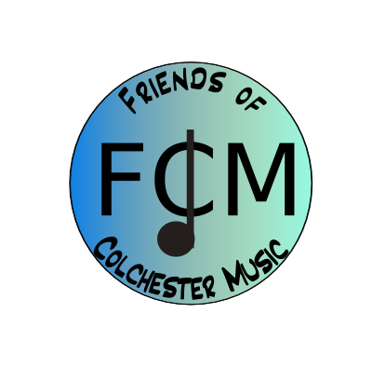

Agenda – Meeting October 15, 2014, 6:30-8:00, CHS Band Room
Overview: Music programs’ needs and fund-raising
- Teachers’ updates
Music Sampler Concert -7pm October 23 at CHS
FCM table at concert – who will be there to cover it? No flowers or DVD’s, just magnets and our presence.
- PR – Sally
- Budget– Laurie
- Fund-raising–Angela
New fund-raiser set to go!
- Spending priorities over year – continuation of discussion that ended last meeting, time to talk tonight!
- Other brief business – 5 minutes
- Next meeting date is November 11.

Sampler – would they like a dvd each? Not selling them though.
Do I have all the okays on filming students
Photos for web-site – really outdated, just took Rousseau off CMS page
Can CHS start the KK sale before the concert so we can talk about it at the table
Are there any festival fees that we should consider?

Funds Raised:
Concerts $2187 total
DVD’s $609
Flowers $766
Magnets $388
Donations $424
Check Donations $850
FCM Fund-Raisers $4520
Total raised this year: $7557 (last year we raised $4000)
Fund-raisers at specific schools, not for FCM - $5000 approx.
So total fund-raising efforts in the CSD for music were over $12,000! (last year we were at about $8300)

Spending:
We spent $4298 on I-pads, scholarships, Count Basie seminar, NYC trip, piano dolly, receptions, festival fees

Balance forward: $5950
(We had started the year with $2691)

