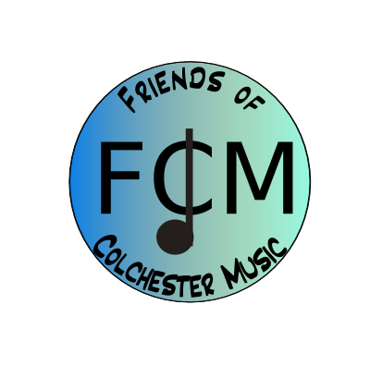

Agenda – Meeting November 15, 2016, 6:30-8:00, MBS Music Room
- Teachers updates
- Fund-raising update –Angela
KK total!
- Budget update – Laurie
- PR update – Sally
Tuba at CMS?
- Concerts: DVD’s, flowers at all. Need three volunteers at each, set-up 45 minutes before. Organize cashbox transfer between volunteers and DVD forms to Wendy asap.

December 14 - CMS Winter Choral concert - 7:00pm - CHS Performance Space

December 18 - CHS, 2 PM winter concert band and chorus combined, please note this is a Sunday!
Rreception – last year was Angela, Chris Towle, Jan, Mary Fran
(Sally can help with drink set-up during jazz)

December 21 - CMS Winter Band concert -7:00pm - CMS Gymnasium

- DonorsChoose.org.
- Teacher’s current needs/requests
- Other business
- Next meeting December 13

