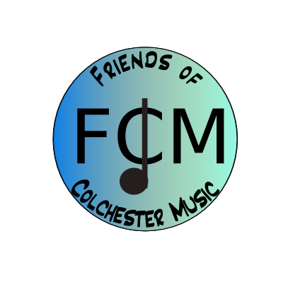

Agenda – Meeting October 13, 2015, 6:30-8:00, CHS Band Room
In attendance: Marie Bouffard, Laurie Pike, Angela Zwonik, Laura Labrie, MaryFran Holly, Martie Mutz, Heidi Carroll, Tyler Mast, Jan Hinnes, Sally Kieny, Evan Peltier
- Teachers updates – 30 minutes
Martie – VMEA (music educators) conference recently. Denise Gagne spole, very inspiring!
Tyler- Busy! Ukelele program up and running in 5th grade, recorder karate in 4th, Beatles unit for 3rd.
CHS - MaryFran – Setting up crowd-rise fundraiser for CHS trip to NYC. Okay given to tie to FCM checking account.
Evan – Pep rally last week, rained! Theater musical coming up. District Festival – strong showing with both band and chorus students.
- Concerts:
Filming – are we okay to film all of CHS? LCATV have these dates already. – Yes.
Should we sell DVD’s?? Need FCM table volunteers – Yes!
October 22, 7pm, CHS Choral Concert - Sally and Heidi
Oct. 29 CHS Band Fall Concert 7 pm – Laurie and Angels
- Recruiting more members – ideas/suggestions – Teachers are the key, recruit for us with emails. We get excellent response to sign-up geniuses.
- Budget– Laurie – looking strong, have $4716 in c/a today.
- PR – Sally – FPF, Spotlight for all events. Submitted large article about all schools to Colchester Sun.
- Front Porch Forums:
Marie – West
Sally – Village
Jeanette still does Malletts Bay
Kim Sonntag will do Bay Creek
Sally has a contact for Clay Point
- Fund-raising–Angela
Coin Drop 9/11 – Raised $490.71
Ski and Board 10/3-10/4 – Raised $760.83
Krispy Kremes starts this week! – Raised $4200 last time. Forms to teachers today!
Also working on Silent Auction for Soiree in February, lots of neat, new prizes. 80 items so far.
- Teacher’s current needs/requests
$125 for trumpet repair for student at CMS – approved
2 more timpani for CHS - $5000-$6000, can buy one at a time. Has 2 of 4 that needs.
Trumpet to buy from a family for $150 – Approved.
Microphone system for CHS theatre – discussed, but need more info and might be included in theatre renovations.
- Other business
- Next meeting date is November 10.

